ITP 359, SUMMER 2024

Homework 5
32 points
Time series forecasting

Use a feed forward neural network to forecast a time series.
32 points (2 points each, except as noted)
Please only submit the Python (from colab) notebook. No need for screenshots.
- Download global temperature anomaly from 1850 to the present. Temperatures should be monthly. https://www.ncei.noaa.gov/access/monitoring/climate-at-a-glance/global/time-series/globe/land/1/8/1850-2023
- Import the temperature data into a python notebook.
- Convert the Year column into datetime (from pandas)
- Plot the temperature anomaly vs year.
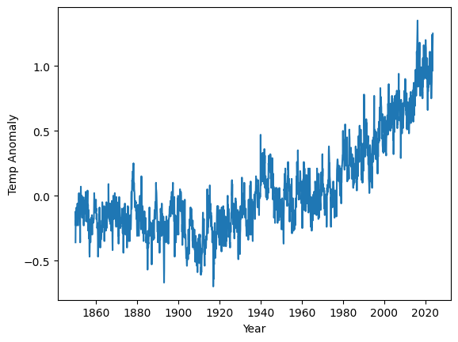
- Save only the temperature anomaly into a 2D numpy array.
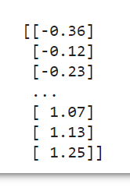
- Scale the temperature using minmaxscaler.
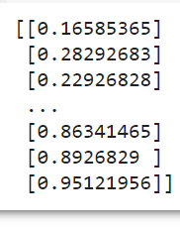
- Convert the temperature array into sequences of n monthly temperatures that are shifted by one month in each row of the array. Call this array X. y is the next month’s temperature (1D array). The length of the sequence n is your choice (e.g. 24).
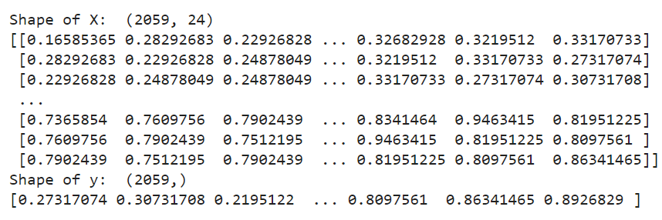
- Build a dense feedforward neural network with sequences of temperature as input and y as the output.
- Use mean squared error as the loss function.
- Train the network.
- Predict the next month’s temperature for all sequences in X. Inverse scale the temperature.
- Score the model.
- Now plot the predicted temperatures and the actual temperatures.
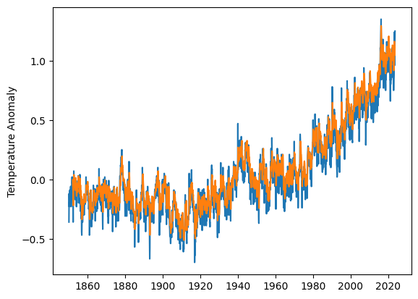
- Now predict the temperature for the next 24 months into the future. For every month in the future, you will predict the temperature. Each month’s predicted temperature should be stored back into the sequence for predicting the following month. So, each y value becomes part of X. (6 points)
